Application form for Silverdale & Arnside Arts Festival 27th and 28th June 2026
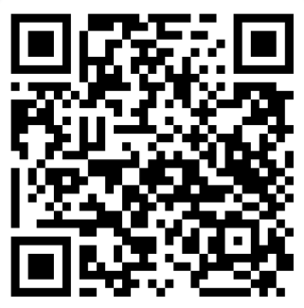
DEADLINE for applications Thursday 30th April Public Meeting Wednesday 25th February Silverdale Hotel 7pm
This form is available on our website. Either click the following link or use the QR code:
https://silverdale-arnside-art-festival.co.uk/apply
GIVEN NAME | BUSINESS NAME
PREFERRED VENUE  Your options are…. A venue which we will allocate to you when you pay. You can specify which village, Arnside or Silverdale, or a venue that you provide for yourself. There are also outdoor gazebo places at Arnside WI, no electric. Storth Village also has venues but participants usually find their own. | Please underline  Arnside EI-£30 Arnside WI-£30  Arnside WI Outdoor gazebo place £15  Silverdale Venue TBC (depending on number of stalls)  Your own venue- please provide address here
EMAIL ADDRESS
HOME ADDRESS
PHONE NUMBER
WEBSITE
FACEBOOK AND/OR INSTAGRAM ADDRESS
NATURE OF ART/CRAFT (eg. Painter, textiles, ceramics etc
Are you willing to let information on this form be used in Arts Festival publicity material and on the website? If you answer NO please specify what you do not wish to be published. | We will need to publish your name and art/craft.
Application Fee is £10
There is NO Table fee charge for using your own venue.
If you wish to pay cash in Arnside please deliver to Gilli Slater 48 Silverdale Road Arnside LA50DZ, or
FOR CHEQUES OR CASH to Kay Loch Old Cove Lea, Cove Lane, Silverdale LA5 0SZ
BACS DETAILS Name Kay Melanie Loch Sort code 07-14-90 Account number 52468743
Reference your name and SAAAF
YOUR PLACE IS NOT BOOKED UNTIL YOU HAVE PAID THE APPLICATION FEE of £10
Please underline your payment method
£10 Application Fee: Cash Cheque BACS
£ Table Fee: Cash Cheque BACS OWN VENUE
TERMS AND CONDITIONS
- All exhibitors must send a text( maximum 40 words) describing their work and 3 good quality jpeg images to info@silverdale-arnside-art-festival.co.uk by 30th APRIL please to go on to the website.
- All exhibitors are responsible for their own public liability insurance.
- All exhibitors are expected to advertise the event as widely as possible using social media and local postering.
- PLEASE RETURN TO info@silverdale-arnside-art-festival.co.uk

